Sarah Ildza
ENGL 21003
Prof. Jane Bolster
Self-Assessment

This is an assessment of myself as both an individual and a writer. I am going to discuss how I have changed as a writer throughout this semester and what I have taken away from comments on my writing from not only my professor but my peers as well.
At the start of the semester, I came into writing for the sciences confident in my ability to write papers, but I also came eager to expand my skills. My writing class in the Fall 2018 semester helped me grow in writing more concisely with an appropriate amount of detail. My writing class during this semester helped me grow in adding as much detail as possible and annotate what my writing is intended to portray.
The first paper I wrote was a technical description in which I learned how to use imagery and a lot of detail to describe how a piece of technical machinery works. I wrote my paper on how an ultrasound works. I got an 83 (B-) on this assignment which I was okay with because I was not sure what kind of grade to expect. I used an image to help explain an ultrasound and that improved my paper. The feedback I got was “This is brief. Could you provide specific examples?” As I went over the paper, I could see that there definitely was space for improvement and I could provide more specific examples, so I kept that in mind for my next paper.
I did not like writing the scientific report analysis. First of all, I had to read a 20-page report that followed a specific writing method, called the “IMRAD” method, and then discuss it. I had never written a report on a report before so I knew this assignment would be challenging and it was. I received a 79 (C+) on this paper. I realized that science requires a lot of imagery, so I included a screenshot of the results derived from the data done in the study, but. I got my paper back with a comment on the table saying that it was “not necessary”. I felt like it was a good addition and I still feel like it was a good addition because it added detail to my paper and a form of “proof” to my information. After I got my paper back, I noticed that at some point in the conclusion I got extremely redundant and I used the word “important” 5 times in one paragraph. Oops! I think I got the grade I deserved.
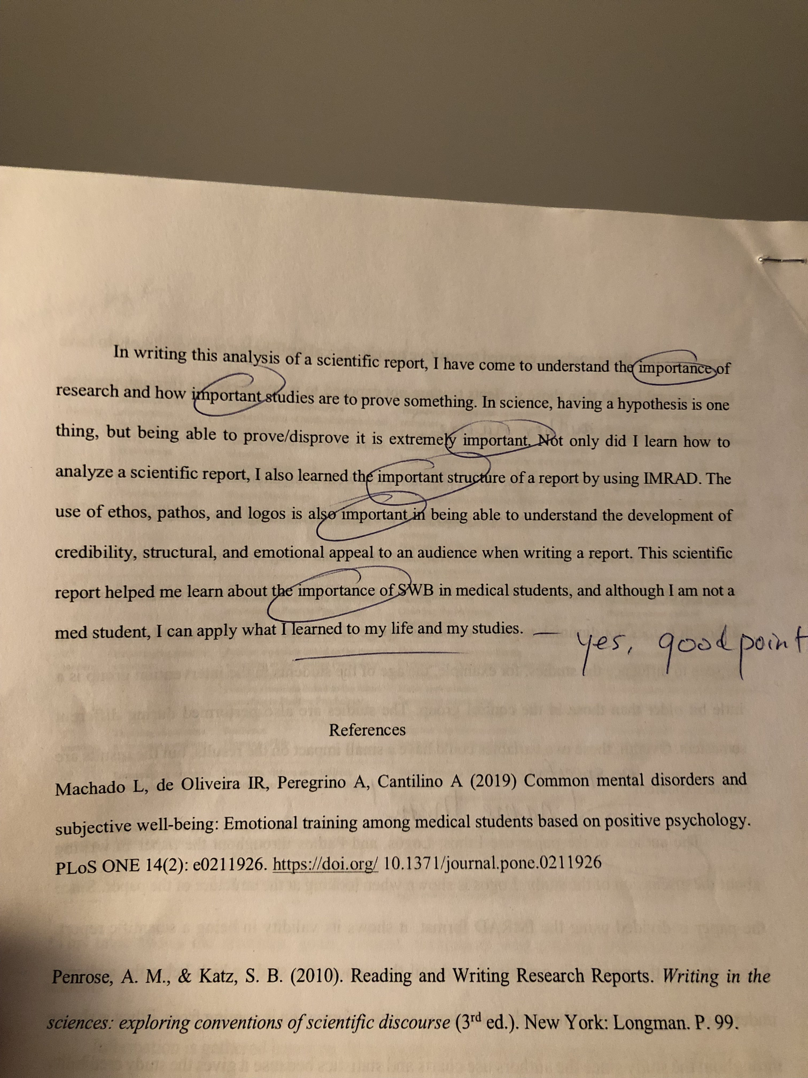

The next paper I wrote was the scientific controversy paper with the annotated bibliography. The controversy I chose was “GMO vs. Organic Food”. I liked writing this paper because the topic I chose interested me but the overall outline of how the assignment was supposed to be written was extremely unclear to me. On the first draft, I found at least three sources and I wrote discussing them and what they were saying. I both summarized it and I analyzed it. The feedback I got was positive as well saying that I was doing a good job and should continue what it was doing. On the other hand, during class, we were asked to only analyze, and the summary was supposed to be left for the annotated bibliography. What I was told a few weeks before was that the annotated bibliography was supposed to be a more personal description of the author and whether they are a reliable source. My feedback on the first draft confused me more than it was supposed to help me. My peer review also seemed useless to me because my reviewer was extremely shy, so she did not speak to me at all, so it felt like I got zero feedback. Her paper was interesting to read though, and it gave me a tiny glimpse of what we were supposed to do since I was very lost. I spent so much time writing this paper because I genuinely had no idea what to do and how to do it. One thing I kept thinking was: How am I supposed to analyze something without stating what that “something” that I am analyzing is saying? For the scientific Controversy part of this paper, I received an 80 and I got an 81 for the annotated bibliography. An annotated bibliography was something I had never done before so writing it was also extremely confusing but also kind of interesting because it definitely is important to figure out if a source is reliable or not. This was a two-in-one type of assignment and I was glad when I finally got it over with.
The last assignment done for this class was the collaborative research project. Once again, the topic was interesting but working in groups is not my favorite thing in the world. In fact, it's one of the things I hate the most. My group was reliable but as mentioned in my journals, I felt like we lacked a “group leader”. I also did not understand the point of keeping a journal for this project, but I used it as a vent session, and it was kind of therapeutic because group projects can be a long haul. I liked our topic of climate change so typing my part of the paper came without a problem and I found a really good primary source that I felt like it helped our paper. Our presentation also raised a lot of questions and awareness into the classroom. This being the last assignment felt like the last obstacle I needed to accomplish to finish with writing for this semester. I was correct until I realized I needed to do a self-assessment as well. Anyways, the group project has not yet been graded, but my expectations are high.
Overall, this semester seemed easier to me than my writing class last semester, but it was also very different. One thing I disagreed with doing was peer reviews on our final draft, after it was graded. I felt like since the paper was already graded, reviewing it with a peer to better it was so pointless because a higher grade could not be achieved. I would have already received feedback from the professor so having my peer add their input to the graded version felt like a waste of time.
One thing I somewhat liked was New York Times article summaries because it helped me realize more of what was going on in the world. I never really sit down and read newspapers or even news, but these assignments brought me to do so. Hopefully I will find myself reading the New York Times on my own time now.

