Sarah Ildza
Jane Bolster
ENGL 21003
Technical Description
How Does an Ultrasound Work?

Perhaps you are a pregnant individual, or maybe you are just curious on how ultrasounds work. Maybe you are in the process of getting treatment that involves the use of an ultrasound for therapeutic reasons. This paper does not have any specific audience; it is written so that it is intended for a vague audience spectrum. Whatever it is that pulled you in to think about how an ultrasound works, this paper should clarify it for you.
Ultrasounds are an interesting process used to track the process of every healing individual, as well as every pregnant person throughout their stages of pregnancy. There are two uses for ultrasounds: therapeutic and diagnostic. Therapeutic ultrasounds serve to heal people that have harmed tissue in their body. Diagnostic ultrasounds are used mainly in tracking the stages of development of an unborn child. This paper is going to primarily dissect the use on an ultrasound on a pregnant individual, and later, it will dive into therapeutic ultrasounds. (Nationalinstitutesofhealth.com).
One to develop a sonogram for pregnant people. It is an amazing process because it shows a very important aspect in a pregnant individual and their family’s life. An ultrasound machine makes it possible to track the development of a child, from the moment that he/she is just the size of a grape, to later when he/she is ready to come out. Ultrasounds help in determining so many things about the child. For example, the gender, if a someone is carrying twins, if there are any birth defects, and more. Overall, without going to the ultrasound procedure, parents would have very little information available regarding many concerns they may have about their soon to be born child. One amazing thing about ultrasounds is that they can formulate pictures and live videos of the child. Those pictures are called sonograms. A sonogram is the image on screen or printed out of how the child is seen inside of a womb. Although not much is seen, the development of life is so significant and beautiful which is why ultrasounds and sonograms hold more significance than credited for. An ultrasound is almost like an x-ray, because you can see inside the body, but they are less harmful. Ultrasounds are preferred for pregnant individuals because they do not use and radiation, so the baby is not harmed by it.

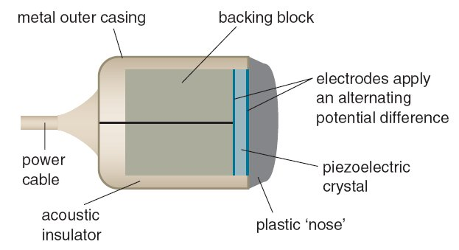http://www.genesis.net.au/~ajs/projects/medical_physics/graphics/transducer.jpg

Before starting the ultrasound, the technician rubs a specials type of lubricant on the female's stomach. This lubricant helps the ultrasound machine detects the soundwaves that will be transmitted, and it also prevents friction. The gel also “stops air pockets from forming between the skin and the transducer, stopping ultrasound waves from entering someone’s body” (NationalInstitueofHealth.com). The whole point of an ultrasound on a pregnant individual is to keep observe the developing fetus without harming it so the main point is to keep any harmful waves from entering one’s body. The procedure lasts roughly half an hour, and it is completely harmless to both the female and the baby. The only thing that might be uncomfortable is the jelly rubbed on the individual’s stomach.
A video on YouTube called “How Ultrasound Works”, it simplifies and describes the process within 60 seconds. The main part of the ultrasound machine is called a “transducer (blue part as shown above), that creates piezoelectric crystals. Piezoelectric crystals are any type of crystal that can differentiate materials when in a mechanical process. In the case of an ultrasound, piezoelectric crystals can find the baby in someone’s stomach. Piezoelectric crystals vibrate which allows them to produce high frequency sound waves. Those sound waves are used to see inside a pregnant person’s stomach, which is initially what an ultrasound is. These sound waves act almost as an x-ray machine. They go right through the skin and directly into one’s body where they can sense different tissues, that hold different densities. The waves bounce back and forth from the machine to the individual’s body, which allow the piezoelectric crystals to convert them into electric signals. Since the ultrasound machine is connected to a computer, the computer is then able to process the electric signals, and that creates an image on the screen. As the doctor moves the ultrasound machine around on an individual's stomach, the baby is found because the sound waves transmitted between the baby and the piezoelectric crystals allow the machine to differentiate the densities of tissue between a woman’s uterus and the baby (“How Ultrasound Works”). This results in images of the baby being made on the computer screen. By moving the ultrasound machine, the images of the baby turn into a live video of the child moving and it is possible to even detect the sound of the heartbeat, bringing families tremendous amounts of joy because they can hear and see living proof of their newly developed life. The way that an ultrasound works is extremely similar to a technique found in nature. A technique called echolocation that is used by bats and whales to help them locate their prey. It is similar because the process of echolocation uses soundwaves to detect the location of something, and that same technique is used by the ultrasound machine. The same way, it is like a sonar machine used by submarines to detect its surroundings (Howstuffworks.com).
Ultrasounds are not only used to detect babies in pregnancies. There are many more uses for ultrasounds. There are “therapeutic ultrasounds” that are just like diagnostic ultrasounds except that they do not produce images. The purpose of this is to take closer looks at the tissues in someone’s body to detect and defects. Ultrasounds are useful in being able to move tissue, get rid of blood clots, and delivering drugs to specific organs in the body. The main question is, how does this work? This works the same way that an ultrasound works when detecting a baby. The piezoelectric crystals bounce back and forth between the transducer and the tissue in someone’s body. The use of the emitted soundwaves bouncing back and forth between the transducer and the detected tissue is used to figure out the placement of the tissue in someone’s body. Since the ultrasound can move and fix tissue without harming it, it is a very important tool in helping people (NationalInstitueofHealth.com).
Overall, when someone hears the word “ultrasound”, they automatically associate it with pregnancies because people do not know the more general uses that an ultrasound machine can perform. Ultrasounds work to detect how the tissue inside a person are preforming as well as how babies are developing. Hopefully this description brought clarity about ultrasounds and how they work.

Works Cited
Radiological Society of North America, et al. “General Ultrasound.” RadiologyInfo.org, RadiologyInfo.org, www.radiologyinfo.org/en/info.cfm?pg=genus.

“Ultrasound.” National Institute of Biomedical Imaging and Bioengineering, U.S. Department of Health and Human Services, www.nibib.nih.gov/science-education/science-topics/ultrasound.

Craig Freudenrich, Ph.D. “How Ultrasound Works.” HowStuffWorks Science, HowStuffWorks, 28 June 2018, science.howstuffworks.com/ultrasound1.htm.

Gov, NIBIB, director. How Ultrasound Works. YouTube, YouTube, 5 June 2015, www.youtube.com/watch?v=I1Bdp2tMFsY.

